**ONLINE VOTING SYSTEM**

Submitted in partial fulfillment of the requirements of

**University of Mumbai**

For the Degree of

## Bachelor of Engineering in CSE (IOT)

Submitted by

## MS. PURVA KAMBLE [ROLL NO.: 27]

## MS. ASHWINI MESHRAM [ROLL NO.: 38] MR. PANKAJ PAWAR [ROLL NO.: 43]

## MS. MINAL THOMBARE [ROLL NO.: 65]

Under the guidance of

## PROF. RISHIKESH YADAV



**DEPARTMENT OF CSE (AIML/IOT)**

## SMT. INDIRA GANDHI COLLEGE OF ENGINEERING

Ghansoli, Navi Mumbai - 400701

## Academic year: 2022-2023

**Vision**

To provide employable CSE-AIML engineers for Society and Industry needs.

**Mission**

M1: Empower students with a strong basic foundation.

M2: Develop technical and non technical Skills for lifelong learning.

M3: To promote student’s interest in higher studies, research and entrepreneurship to meet global challenges.

PEO1: Graduates will be prepared for analyzing, designing, developing AIML based software with creativity.

PEO2: Graduates will be skilled in the use of modern tools for problem solving and analyzing industrial and societal requirements.

PEO3: Graduates will be exhibited professionalism, inter-personal skills and constant learning to develop management qualities.

PSO1: Ability to analyze, design and develop applications by adopting the dynamic nature of Software developments

PSO2: Ability to use knowledge in Artificial Intelligence and Machine Learning to solve real world problems and identify the research gaps and render solutions with innovative ideas.

**Project Report Approval for T.E.**

This project report entitled **“Online Voting System”**

By

**Ms. Purva Kamble** (Roll No.: 27) **Ms. Ashwini Meshram** (Roll No.: 38)

**Mr. Pankaj Pawar** (Roll Noo.: 43) **Ms. Minal Thombare** (Roll No.: 65)

are approved for the degree of Bachelor of Engineering in Computer Engineering, Semester V, University of Mumbai.





Examiner 1 Examiner 2 Prof.Rishikesh Yadav Prof. Sarita Khedikar

Project Guide Internal Guide



Prof. Sonali.Deshpande Dr. Sunil Chavan

Head of Department Principal

Date: 09/11/2022

Place: Ghansoli, Navi Mumbai.

## Declaration

We declare that this written submission represents our own ideas in our own words and where others ideas or words have been included, we have adequately cited and referenced the original sources. We also declare that we have adhered to all principles of academic honesty and integrity and have not misrepresented or fabricated or falsified any act/data/source in our submission. We understand that any violation of the above will be cause for disciplinary action by the Institute and can also evoke penal action from the sources which have thus not been properly cited or from whom proper permission has not been taken when needed.

___________________________

Ms. Purva Kamble [Roll No.: 27]

___________________________

Ms. Ashwini Meshram [Roll No.: 38]

___________________________

Mr. Pankaj Pawar [Roll No.: 43]

___________________________

Ms. Minal Thombare [Roll No.: 65]

Date: 09/11/2022

Place: Ghansoli, Navi Mumbai.

## Abstract

Title: Online Voting System

The online voting system facilitates the user(voter), candidate and administrator (who will be in charge and will verify all the user and information) to participate in online voting. Our online voting system is highly secured, and it has a simple and interactive user interface. The proposed online portal is secured and has a unique security feature such as unique id generation that adds another layer of security (except login id and password) and gives admin the ability to verify the user information and to decide whether he is eligible to vote or not. It also creates and manages voting and an election detail as all the users must login by user name and password and click on candidates to register to vote. Our system is also equipped with a chat bot that works as a support or guide to the voters, this helps the users in the voting process.

Keywords: HTML, CSS, Java Script, PHP, MYSQL, phpMyAdmin, XAMPP

## List of Abbreviations

* B.E.: Bachelor of Engineering
* DFD: Data Flow Diagram
* VS Code: Visual Studio Code
* GUI: Graphical User Interface
* XAMPP: X-operating system, Apache, Mysql, Php, Perl
* IDE: Integrated development environment
* SQL: Structured Query Language
* HTML: Hypertext Markup Language
* CSS: Cascading Style Sheets

## List of Figures

* Fig.2.2.1 VS Code
* Fig.2.2.2 XAMPP
* Fig.3.1.1 Spiral Model
* Fig.3.2.1 TimeLine
* Fig.5.1 Flow Chart
* Fig.5.2.1 Data Flow Diagram (Level 0)
* Fig.5.2.2 Use Case Diagram
* Fig.5.2.3 Activity Diagram
* Fig. 5.2.4 Class Diagram
* Fig. 5.2.5 E-R Diagram
* Fig. 6.1.1 Dashboard

**Index**

| **Chapter No.** | **Content** | | | **Page No.** |
| --- | --- | --- | --- | --- |
| **I** | **Abstract** | | | i |
| **II** | **List of Abbreviations** | | | ii |
| **III** | **List of Figures & Tables** | | | iii |
| **1** | **Introduction** | | | 1 |
|  | 1.1 | Problem Statement | | 2 |
|  | 1.2 | Objectives | | 2 |
|  | 1.3 | Report Organization | | 2 |
| **2** | **Review of Literature** | | | 3 |
|  | 2.1 | Literature survey | | 4 |
|  | 2.2 | Methodology | | 5 |
|  |  | 2.2.1 | Visual Studio Code (VS Code) | 5 |
|  |  | 2.2.2 | XAMPP | 6 |
| **3** | **Planning and Formulation** | | | 7 |
|  | 3.1 | Project Development Model | | 8 |
|  |  | 3.1.1 | Project Model:Spiral Model | 8 |
|  |  | 3.1.2 | Phases of Spiral Model | 8-10 |
|  |  | 3.1.3 | Advantages of Spiral Model | 10 |
|  |  | 3.1.4 | Disadvantages of Spiral Model | 10 |
|  | 3.2 | Timeline Chart | | 11 |
|  | 3.3 | Feasibility Analysis | | 12 |
|  |  | 3.3.1 | Technical Feasibility | 12 |
|  |  | 3.3.2 | Economic Feasibility | 12 |
|  |  | 3.3.3 | Operational Feasibility | 12 |

| **4** | **Requirement Analysis** | | | 13 |
| --- | --- | --- | --- | --- |
|  | 4.1 | Hardware Requirements | | 14 |
|  | 4.2 | Software Requirements | | 14 |
|  | 4.3 | Functional Requirements | | 14 |
|  | 4.4 | Security Requirements | | 15 |
| **5** | **System Design** | | | 16 |
|  | 5.0 | Design | | 17 |
|  | 5.1 | Flow Chart | | 18 |
|  | 5.2 | UML Diagrams | | 19 |
|  |  | 5.2.1 | DFD Level 0 | 19 |
|  |  | 5.2.2 | Use Case Diagram | 20 |
|  |  | 5.2.3 | Activity Diagram | 21 |
|  |  | 5.2.4 | Class Diagram | 22 |
|  |  | 5.2.5 | E-R Diagram | 23 |
| **6** | **Model Development** | | | 24 |
|  | 6.1 | Model Development | | 25-37 |
| **7** | **Deployment, Maintenance & Conclusion** | | | 38 |
|  | 7.1 | Deployment | | 39 |
|  | 7.2 | Maintenance | | 39 |
|  | 7.3 | Conclusion | | 39 |
|  | **Acknowledgement** | | | 40 |
|  | **References** | | | 41 |

# CHAPTER 1 INTRODUCTION

## Introduction

At their core, online voting systems protect the integrity of your vote by preventing voters from being able to vote multiple times. As a digital platform, they eliminate the need to gather in-person, cast votes using paper, or by any other means (e.g. email, insecure survey software). You may hear an online voting system being referred to as an online election system, an online e voting system, or electronic voting. These all make reference to the same thing: a secure voting tool that allows your group to collect input from your group and closely scrutinize the results in real time.

### Problem Statement

Online Voting System provides the online registration form for the users before voting and makes the users cast their vote online. The system is to be developed with high security and user friendly.

### Objectives

1. Reviewing the existing/ current voting process
2. Coming up with an automated voting system.
3. Validating the system to ensure that only eligible voters are allowed to vote.

### Report Organization

* **In Chapter 2,** we will see the literature survey which will tell us more about the background of the project including the work that has already been done in this field.
* **In Chapter 3,** Planning and Formulation of the project is given. Usage of Spiral model and how we integrated and worked around the model.
* **In Chapter 4,** shines light upon the Requirements that are needed and analysis of the system to uncover the additional requirements of the project.
* **In Chapter 5,** the system proposed is introduced which will tell the deep specification of the project and will tell how the different modules of the system will work, the flow of the project regarding data flow, control flow and other flow of the system.
* **In Chapter 6,** we see the implementation of the algorithm of the project and process of model building.
* **In Chapter 7,** Conclusion of this project is mentioned

# CHAPTER 2 REVIEW OF LITERATURE

## REVIEW OF LITERATURE

### Literature Survey:

India has a parliamentary system as defined by its constitution, with power distributed between the central government and the states. Elections are held once every five years. Candidates are required to file their nomination papers with the Electoral Commission. Then, a list of candidates is published. No party is allowed to use government resources for campaigning. No party is allowed to bribe the candidates before elections. The government cannot start a project during the election period. Campaigning ends by 6:00 pm two days before the polling day. The polling is held between 7:00 am and 6:00 pm. The Collector of each district is in charge of polling. Government employees are employed as poll officers at the polling stations. Electronic Voting Machines (EVM) are being used instead of ballot boxes to prevent election fraud. After the citizen votes his or her left index finger is marked with indelible ink. This practice was instituted in 1962. For the first and second General Elections in 1951-52, and 1957, the ElectionCommission adopted the ‘Balloting System’ of voting. Under this system, every candidate was allotted a separate ballot box at each polling station in a screened compartment and the vote was required only to drop his ballot paper, the centrally pre-printed ballot papers into the ballot box of the candidate of his choice. From the 3rd General Elections in 1962 onwards, the Commission switched over to the marking system of voting. Under this system, a common ballot paper containing the names and election symbols of all contesting candidates is printed on which the voter has to put a mark with an arrow cross mark rubber stamp on or near the symbol of the candidate of his choice. All The marked ballot papers are put into a common ballot box. The Electronic Voting Machines (EVMs) were used for the first time in part of Paravur Assembly Constituency in Kerala in 1982, on experimental basis. Later, the extensive use ofEVMs started in 1998. The EVMs were used at all polling stations in the country in the 14th General Elections to the Lok Sabha in 2004 for the first time. Since then all elections to LokSabha and Legislative Assemblies have been held using EVMs. Much research has been done regarding online voting systems where voters can vote from anywhere without the need for visiting voting centers. The ideas based on online voting system consists of aadhar voting system.

(Reference: https://www.researchgate.net/publication/271550721_Online_voting_system_for_India_based_on_AADHAAR_ID<https://ieeexplore.ieee.org/document/6756265/authors#authors> <http://employmentnews.gov.in/Evolution-of-Electoral-System-of-India.pdf>)

Our project named online voting system will be a website which will help in conducting elections in an efficient way. Voters can register on the website using their aadhar card. The system will verify the eligibility of the voter and voter will be provided with the login credentials .Voter will be asked for their birth date again for verification. Voters will require a password of their choice to log in into the website. Then voters can cast their vote from anywhere. The one who cannot operate the website may go to nearby service centers for help. For political parties, they can register their parties along with their symbol, name of members, candidate information, party profile, etc. The module of a political party can be accessed by the Party leader and the one who is permitted by the party leader. Political parties then can cast votes to only their party by using their login credentials. The system will have all the data to verify that every voter, candidate, political party fulfills the criteria for eligibility and only then can they register for the election. The body conducting election has access to both modules of the website i.e., voter and political party. The election commission can see a list of registered voters, candidates, political parties, cross-verify the data and can correct if something is wrong. Security of the website, data, etc. will be ensured. The system will be highly useful since there will be no need to travel to the voting center so the voting percentage will increase as voters can vote from locations convenient to them. Automatic count, auto verification of voters, etc. are some more benefits of this voting system.

### Methodology

* + 1. **Visual Studio Code (VS Code)**

Visual Studio Code is a streamlined code editor with support for development operations like debugging, task running, and version control. It aims to provide just the tools a developer needs for a quick code-build-debug cycle and leaves more complex workflows to fuller featured IDEs, such as Visual Studio IDE. At its heart, Visual Studio Code features a lightning fast source code editor, perfect for day-to-day use. With support for hundreds of languages, VS Code helps you be instantly productive with syntax highlighting, bracket-matching, auto-indentation, box- selection, snippets, and more[10].

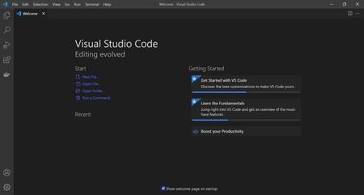

### Fig 2.2.1 Visual Studio

* + 1. **XAMPP**

XAMPP is an abbreviation where X stands for Cross-Platform, A stands for Apache, M stands for MYSQL, and the Ps stand for PHP and Perl, respectively. It is an open-source package of web solutions that includes Apache distribution for many servers and command-line executables along with modules such as Apache server, MariaDB, PHP, and Perl. XAMPP helps a local host or server to test its website and clients via computers and laptops before releasing it to the main server. It is a platform that furnishes a suitable environment to test and verify the working of projects based on Apache, Perl, MySQL database, and PHP through the system of the host itself. Among these technologies, Perl is a programming language used for web development, PHP is a backend scripting language, and MariaDB is the most vividly used database developed by MySQL. The detailed description of these components is given below.

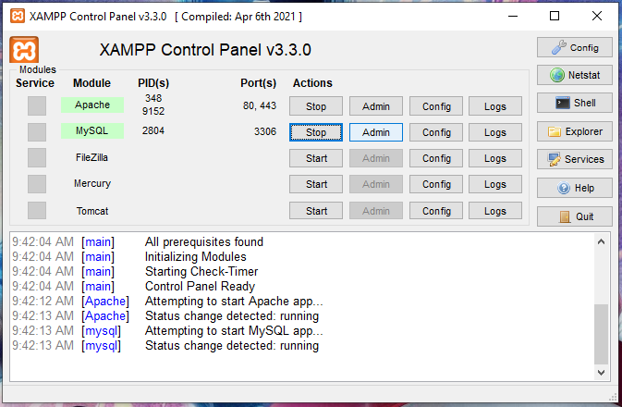

### Fig. 2.2.1 XAMPP

# CHAPTER 3 PLANNING AND FORMULATION

## Planning and Formulation

### Project Development Model

* + 1. **Project Model: Spiral Model**

Spiral model is one of the most important Software Development Life Cycle models, which provides support for Risk Handling. In its diagrammatic representation, it looks like a spiral with many loops. The exact number of loops of the spiral is unknown and can vary from project to project. Each loop of the spiral is called a Phase of the software development process. The exact number of phases needed to develop the product can be varied by the project manager depending upon the project risks. As the project manager dynamically determines the number of phases, so the project manager has an important role to develop a product using the spiral model. The Radius of the spiral at any point represents the expenses(cost) of the project so far, and the angular dimension represents the progress made so far in the current phase.

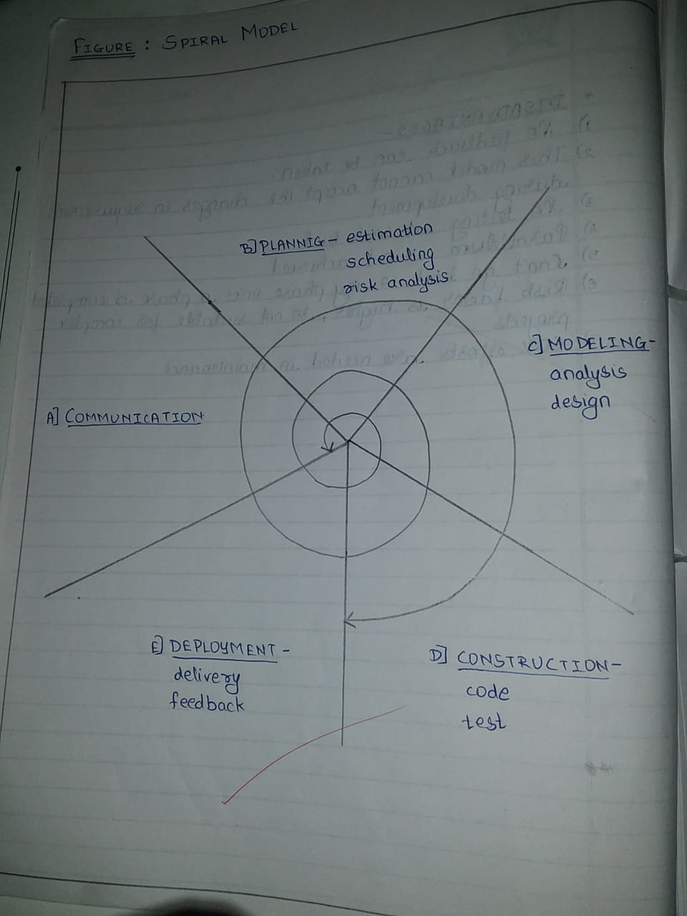

### Fig. 3.1.1 Spiral Model

* + 1. **Phases of Spiral Model:**

**a) Communication:**

Communicating with people, knowing their requirements and views regarding the system. Communicating the other stakeholders and knowing their opinions.

Updation: Implementing the project for state level

**b) Planning:**

Time Limit: 15 days to 1 month

For creation of an online voting system the data of population eligible for voting in the targeted area will be required. Data regarding voters, candidates and political parties of state is required.

General Population of a state: 11.42 crores (Maharashtra State)

Hardware-

• Processor: Intel Core i3

• Hard Disk: 1TB or more

• RAM: 1GB or more

Software-

• Operating System: Windows 10 or higher

• Application Required: XAMPP

• IDE: Visual Studio Code

• Browser: Chrome

• Database: SQL Server

Technically skilled persons are required.

Data of-

• Aadhar card

• Death Certificate

• Other birth date proof and ID.

Of the population is required.

Data of political parties, list of candidates and information about the election process is also required. One by one each module will be made then customer feedback will be taken to know acceptance of the technology. Risks can be sudden change in the team, lack of time, lack of resources, etc.

**c) Modeling:**

Modeling includes analysis of requirements, and designing the software. It will include high-level detailed design as well as overall software architecture.

Languages Required-

Front End: - HTML, CSS

Back End: - PhP

Front End will have GUI (Graphical User Interface) Back End will have Database and the links through which different databases are connected. Modules and database contents will be the same as prototype These all are interlinked with each other. First a prototype with most basic functionalities is prepared in the first spiral using a waterfall model.

**d) Construction:**

In this phase the actual software is constructed. The software design is converted into source code.

Languages used: HTML, CSS, PHP, SQL.

HTML (Hyper Text Markup Language) is the standard markup language for documents designed to be displayed in a web

browser. It can be assisted by technologies such as Cascading Style Sheets(CSS).

PHP (Hypertext Preprocessor) is a server scripting language that can be used to develop dynamic and interactive web pages.

Testing of software is also done in this phase-

White Box Testing-

Performed by the developer to test internal structures or workings of a software.

a) Unit Testing

Checking each module individually

E.g. whether the voter module, admin module and political party module is working properly or not.

b) Integration Testing

Testing the software as a whole

c) Alpha Testing

Initial phase of testing performance of the software from developer side.

Black Box Testing-

Performed by user to check the functionalities of the software.

a) Acceptance Testing

Conducted by users or stakeholders to check whether all the requirements are fulfilled or not.

b) Beta Testing

Second phase of software testing in which a small group of users tries out the software.

**e) Deployment:**

After testing the website will be made available for usage. Deployment will be the same as in the prototype. A database is connected to the server so that the website can access the data of voters, parties, etc. The system can now be implemented at state level for conducting elections. Customer feedback is taken. This feedback is used for preparing the next version of the website. Maintenance refers to fixing the errors faced by the customer and ensuring that the website is running smoothly. Also we may plan for the next version which would include extra security to database as well as other information of the

users.

### Advantage of Spiral Method:

Below are some advantages of the Spiral Model.

* Risk Handling: The projects with many unknown risks that occur as the development proceeds, in that case, Spiral Model is the best development model to follow due to the risk analysis and risk handling at every phase.
* Good for large projects: It is recommended to use the Spiral Model in large and complex projects.
* Flexibility in Requirements: Change requests in the Requirements at a later phase can be incorporated accurately by using this model.
* Customer Satisfaction: Customers can see the development of the product at the early phase of the software development and thus, they habituated with the system by using it before completion of the total product.

### Disadvantage of Spiral Method:

Below are some main disadvantages of the spiral model.

* Complex: The Spiral Model is much more complex than other SDLC models.
* Expensive: Spiral Model is not suitable for small projects as it is expensive.
* Too much dependability on Risk Analysis: The successful completion of the project is very much dependent on Risk Analysis. Without very highly experienced experts, it is going to be a failure to develop a project using this model.
* Difficulty in time management: As the number of phases is unknown at the start of the project, so time estimation is very difficult.

### Timeline Chart

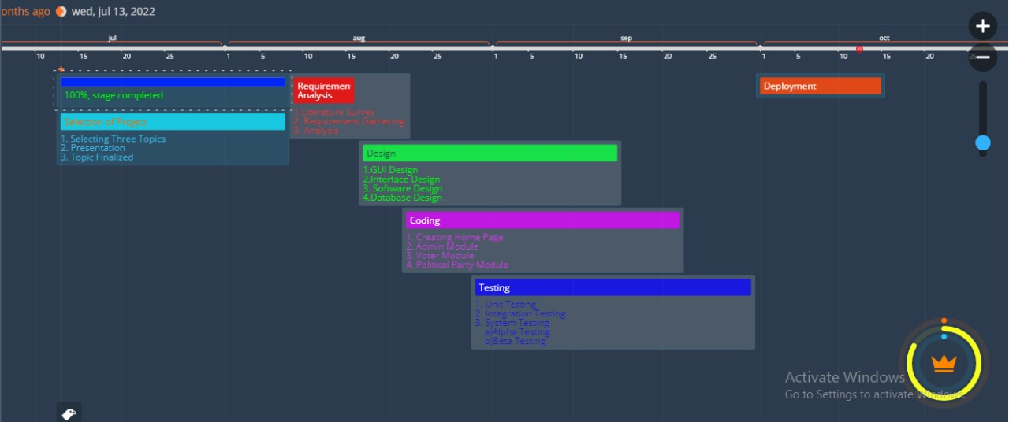

**Table 3.1 Timeline Chart**

### Feasibility Analysis

Next step in analysis is feasibility study. By performing a feasibility study the scope of the system will be defined completely. Most computer systems are developed to satisfy a known user requirement. This means that the first event in the life cycle of a system is usually the task of studying whether it is feasible to computerize a system under consideration or not. Once the decision is made, a report is forwarded and it is known as Feasibility Report. The feasibility is studied under the following contexts:

### Technical Feasibility

It involves determining whether or not a system can actually be constructed to solve the problem at hand. The technical issues raised during the feasibility stage of investigation are related to achievability of project’s goal and possibility of completion of project.

### Economical Feasibility:

This feasibility deals with the cost/benefit analysis. A number of intangible benefits like user friendliness, robustness and security were pointed out. The cost that will be incurred upon the implementation of this project would be quite nominal.

### Operational Feasibility:

The developed system will be very reliable and user friendly. All the features and operations that we will implement in our project are possible to implement and thus feasible. This will facilitate easy use and adoptability of the system. With the use of menus, and proper validation required it becomes fully understandable to the common user and operational with the user.

# CHAPTER 4 REQUIREMENTS ANALYSIS

## 4. Requirements Analysis

### Hardware Requirement

* + 1. Processor: Intel Core i3 (9th Gen)
    2. Hard Disk: 4 GB or more
    3. Computer / Laptop
    4. RAM: 512 MB or above

### Software Requirement

1. Operating System: Windows 10
2. Application Required: XAMPP
3. IDE: Visual Studio Code
4. Browser: Chrome
5. Database: SQL server
6. Front End: HTML, CSS
7. Back End: PHP

### Functional Requirement

* + 1. In software engineering, a functional requirement defines a function of a software system or its component. A function is described as a set of inputs, the behavior, and outputs. Functional requirements may be calculations, technical details, data manipulation and processing and other specific functionality that define what a system is supposed to accomplish.
    2. PHP:Backend of our project is based on PHP as it provides good functionalities for the working of the project.
    3. Mobility: The voter should not be restricted to cast his ballot at a single poll-site at his home precinct.

• Realistic: Voters shall be able to vote from any poll-site within the nation.

• Unrealistic/Expensive: Voters shall be able to vote from any county-controlled kiosk (situated at public places such as banks, shopping malls, etc.) within the nation. (Unrealistic because of logistical and cost issues).

• Infeasible: Voters shall be able to vote from virtually anywhere using an Internet connection. (Infeasible both for technical security issues as well as social science issues).

* + 1. 2. Convenience: The system shall allow the voters to cast their votes quickly, in one session, and should

not require many special skills or intimidate the voter (to ensure Equality of Access to Voters).

* + 1. 3. User-Interface: The system shall provide an easy-to-use user-interface. Also, it shall not

disadvantage any candidate while displaying the choices (e.g., by requiring the user to scroll down to see the last few choices).

### Security Requirements

* + 1. Voter Authenticity: Ensure that the voter must identify himself / herself(with respect to the registration database) to be entitled to vote. If voting other than at his home precinct, the voter may be asked to show some legal identification document.
    2. Registration: The voter registration shall be done in person only. However, the computerized registration database shall be made available to polling-booths all around the nation.
    3. Voter Anonymity: Ensure that votes must not be associated with voter identity.
    4. System Integrity: Ensure that the system cannot be re-configured during operation.
    5. Data Integrity: Ensure that each vote is recorded as intended and cannot be tampered with in any

manner, once recorded (i.e., votes should not be modified, forged or deleted without detection).

## CHAPTER 5 SYSTEM DESIGN

**System Design**

**Design**

Languages Required-

Front End: - HTML, CSS

Back End: - PhP

Front End will have GUI (Graphical User Interface)

The Back End will have a Database and the links through which different databases are connected.

Website will have different modules: -

Voter Module-

Voter Registration

Voter Login

Voting

Voter Logout

Political Party Module-

Party Registration

Party Login

Party Profile

Voting

Logout

Admin Module-

View Voter Module

View Political Party Module

Updating /Correction if required

Counting of votes

Back End-

Database which contain data about-

Aadhar Card Details

Death Certificate Details

Voter’s ID

Vote count for political party

Other required ID proofs.

These all are interlinked with each other.

* 1. **Flow Chart**

A flowchart is a type of diagram that represents a workflow or process. A flowchart can also be defined as a diagrammatic representation of an algorithm, a step-by-step approach to solving a task.

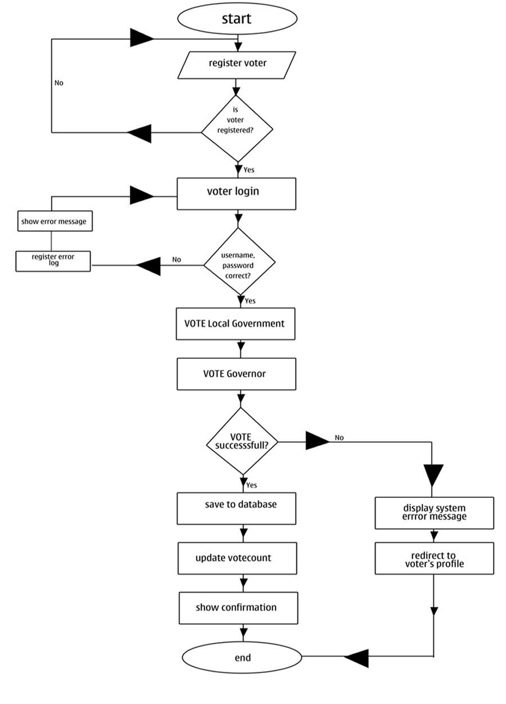

This flow chart represents flow of data or say the users flow while accessing the software.UML Diagrams

* + 1. **DFD Level 0 Diagram**

DFD Level 0 is also called a Context Diagram. It's a basic overview of the whole system or process being analyzed or modeled. It's designed to be an at-a-glance view, showing the system as a single high-level process, with its relationship to external entities.

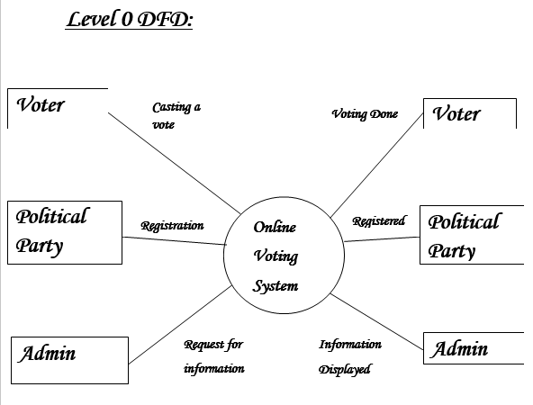

* + 1. **Use Case Diagram**

A UML use case diagram is the primary form of system/software requirements for a new software program underdeveloped. Use cases specify the expected behavior (what), and not the exact method of making it happen (how). Use cases once specified can be denoted both textual and visual representation (i.e. use case diagram)

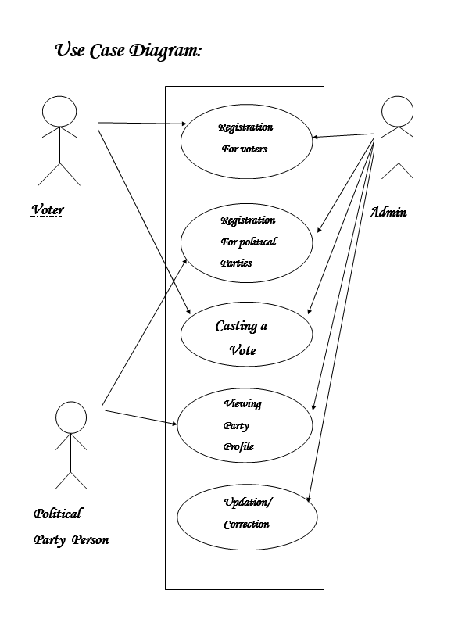

* + 1. **Activity Diagram**

Activity diagram is another important diagram in UML to describe the dynamic aspects of the system. Activity diagram is basically a flowchart to represent the flow from one activity to another activity. The activity can be described as an operation of the system. The control flow is drawn from one operation to another. This flow can be sequential, branched, or concurrent. Activity diagrams deal with all type of flow control by using different elements such as fork, join, etc

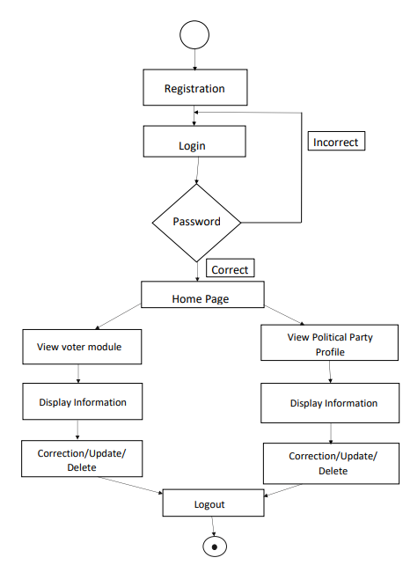

* + 1. **Class Diagram**

In software engineering, a class diagram in the Unified Modeling Language (UML) is a type of static structure diagram that describes the structure of a system by showing the system's classes, their attributes, operations (or methods), and the relationships among objects.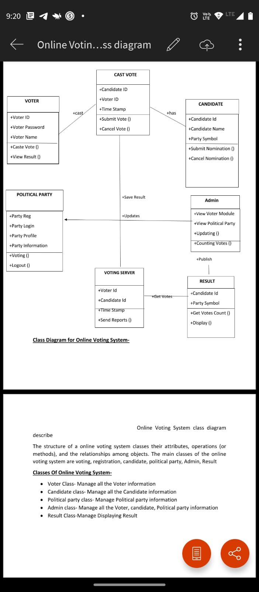

* + 1. **E-R Diagram**

An entity relationship diagram (ERD), also known as an entity relationship model, is a graphical representation that depicts relationships among people, objects, places, concepts or events within an information technology (IT) system.

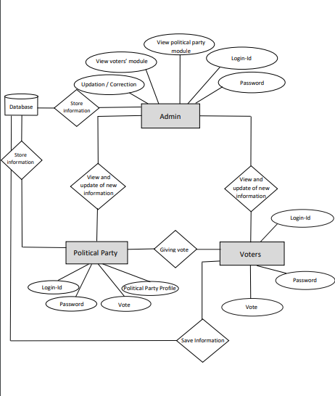

**CHAPTER 6**

**MODEL DEVELOPMENT**

## 6. Model Development

**6.2 Model Development**

### # Implementation of GUI of the system

<?php include 'includes/session.php'; ?>

<?php include 'includes/header.php'; ?>

<body class="hold-transition skin-blue layout-top-nav">

<div class="wrapper">

<?php include 'includes/navbar.php'; ?>

<div class="content-wrapper">

<div class="container">

<!-- Main content -->

<section class="content">

<?php

$parse = parse_ini_file('admin/config.ini', FALSE, INI_SCANNER_RAW);

$title = $parse['election_title'];

?>

<h1 class="page-header text-center title"><b><?php echo strtoupper($title); ?></b></h1>

<div class="row">

<div class="col-sm-10 col-sm-offset-1">

<?php

if(isset($_SESSION['error'])){

?>

<div class="alert alert-danger alert-dismissible">

<button type="button" class="close" data-dismiss="alert" aria-hidden="true">&times;</button>

<ul>

<?php

foreach($_SESSION['error'] as $error){

echo "

<li>".$error."</li>

";

}

?>

</ul>

</div>

<?php

unset($_SESSION['error']);

}

if(isset($_SESSION['success'])){

echo "

<div class='alert alert-success alert-dismissible'>

<button type='button' class='close' data-dismiss='alert' aria-hidden='true'>&times;</button>

<h4><i class='icon fa fa-check'></i> Success!</h4>

".$_SESSION['success']."

</div>

";

unset($_SESSION['success']);

}

?>

<div class="alert alert-danger alert-dismissible" id="alert" style="display:none;">

<button type="button" class="close" data-dismiss="alert" aria-hidden="true">&times;</button>

<span class="message"></span>

</div>

<?php

$sql = "SELECT * FROM votes WHERE voters_id = '".$voter['id']."'";

$vquery = $conn->query($sql);

if($vquery->num_rows > 0){

?>

<div class="text-center">

<h3>You have already voted for this election.</h3>

<a href="#view" data-toggle="modal" class="btn btn-flat btn-primary btn-lg">View Ballot</a>

</div>

<?php

}

else{

?>

<!-- Voting Ballot -->

<form method="POST" id="ballotForm" action="submit_ballot.php">

<?php

include 'includes/slugify.php';

$candidate = '';

$sql = "SELECT * FROM positions ORDER BY priority ASC";

$query = $conn->query($sql);

while($row = $query->fetch_assoc()){

$sql = "SELECT * FROM candidates WHERE position_id='".$row['id']."'";

$cquery = $conn->query($sql);

while($crow = $cquery->fetch_assoc()){

$slug = slugify($row['description']);

$checked = '';

if(isset($_SESSION['post'][$slug])){

$value = $_SESSION['post'][$slug];

if(is_array($value)){

foreach($value as $val){

if($val == $crow['id']){

$checked = 'checked';

}

}

}

else{

if($value == $crow['id']){

$checked = 'checked';

}

}

}

$input = ($row['max_vote'] > 1) ? '<input type="checkbox" class="flat-red '.$slug.'" name="'.$slug."[]".'" value="'.$crow['id'].'" '.$checked.'>' : '<input type="radio" class="flat-red '.$slug.'" name="'.slugify($row['description']).'" value="'.$crow['id'].'" '.$checked.'>';

$image = (!empty($crow['photo'])) ? 'images/'.$crow['photo'] : 'images/profile.jpg';

$candidate .= '

<li>

'.$input.'<button type="button" class="btn btn-primary btn-sm btn-flat clist platform" data-platform="'.$crow['platform'].'" data-fullname="'.$crow['firstname'].' '.$crow['lastname'].'"><i class="fa fa-search"></i> Platform</button><img src="'.$image.'" height="100px" width="100px" class="clist"><span class="cname clist">'.$crow['firstname'].' '.$crow['lastname'].'</span>

</li>

';

}

$instruct = ($row['max_vote'] > 1) ? 'You may select up to '.$row['max_vote'].' candidates' : 'Select only one candidate';

echo '

<div class="row">

<div class="col-xs-12">

<div class="box box-solid" id="'.$row['id'].'">

<div class="box-header with-border">

<h3 class="box-title"><b>'.$row['description'].'</b></h3>

</div>

<div class="box-body">

<p>'.$instruct.'

<span class="pull-right">

<button type="button" class="btn btn-success btn-sm btn-flat reset" data-desc="'.slugify($row['description']).'"><i class="fa fa-refresh"></i> Reset</button>

</span>

</p>

<div id="candidate_list">

<ul>

'.$candidate.'

</ul>

</div>

</div>

</div>

</div>

</div>

';

$candidate = '';

}

?>

<div class="text-center">

<button type="button" class="btn btn-success btn-flat" id="preview"><i class="fa fa-file-text"></i> Preview</button>

<button type="submit" class="btn btn-primary btn-flat" name="vote"><i class="fa fa-check-square-o"></i> Submit</button>

</div>

</form>

<!-- End Voting Ballot -->

<?php

}

?>

</div>

</div>

</section>

</div>

</div>

<?php include 'includes/footer.php'; ?>

<?php include 'includes/ballot_modal.php'; ?>

</div>

<?php include 'includes/scripts.php'; ?>

<script>

$(function(){

$('.content').iCheck({

checkboxClass: 'icheckbox_flat-green',

radioClass: 'iradio_flat-green'

});

$(document).on('click', '.reset', function(e){

e.preventDefault();

var desc = $(this).data('desc');

$('.'+desc).iCheck('uncheck');

});

$(document).on('click', '.platform', function(e){

e.preventDefault();

$('#platform').modal('show');

var platform = $(this).data('platform');

var fullname = $(this).data('fullname');

$('.candidate').html(fullname);

$('#plat_view').html(platform);

});

$('#preview').click(function(e){

e.preventDefault();

var form = $('#ballotForm').serialize();

if(form == ''){

$('.message').html('You must vote atleast one candidate');

$('#alert').show();

}

else{

$.ajax({

type: 'POST',

url: 'preview.php',

data: form,

dataType: 'json',

success: function(response){

if(response.error){

var errmsg = '';

var messages = response.message;

for (i in messages) {

errmsg += messages[i];

}

$('.message').html(errmsg);

$('#alert').show();

}

else{

$('#preview_modal').modal('show');

$('#preview_body').html(response.list);

}

}

});

}

});

});

</script>

</body>

</html>

### 

### Fig. 6.2.1 Dashboard

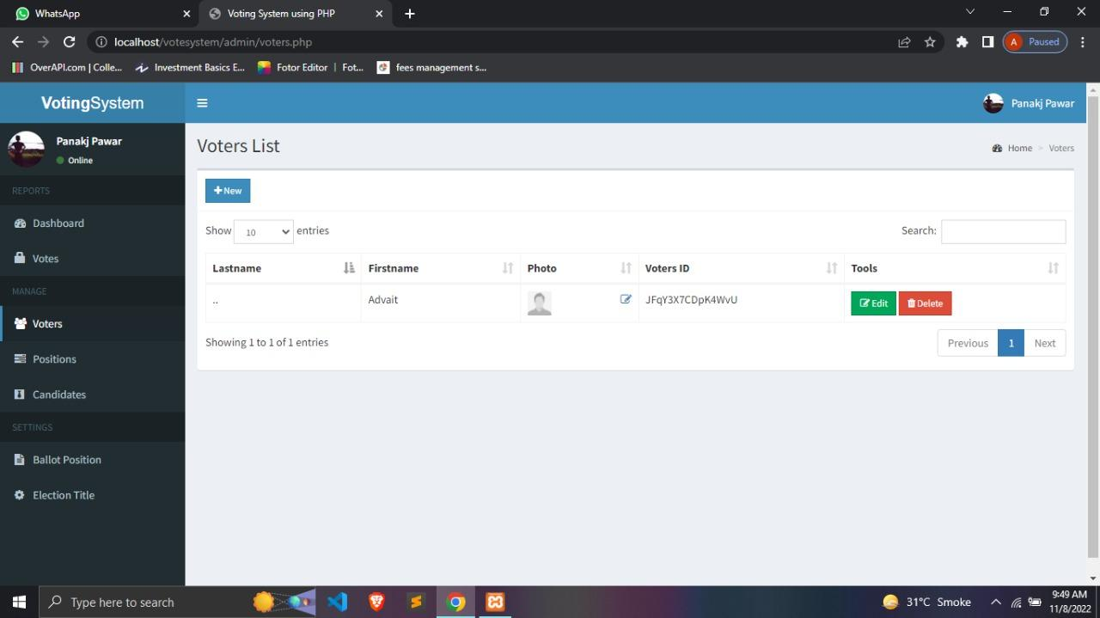

### 

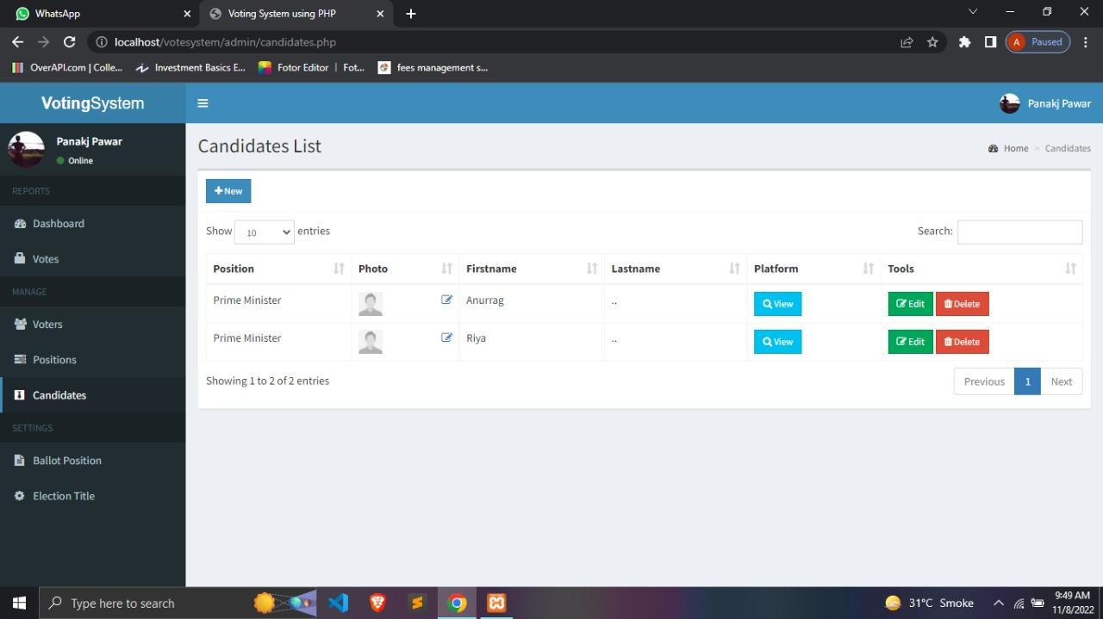

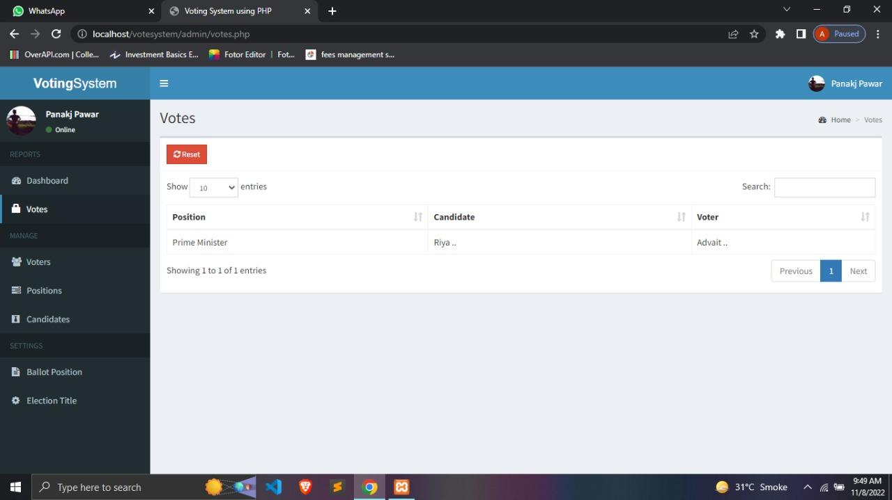

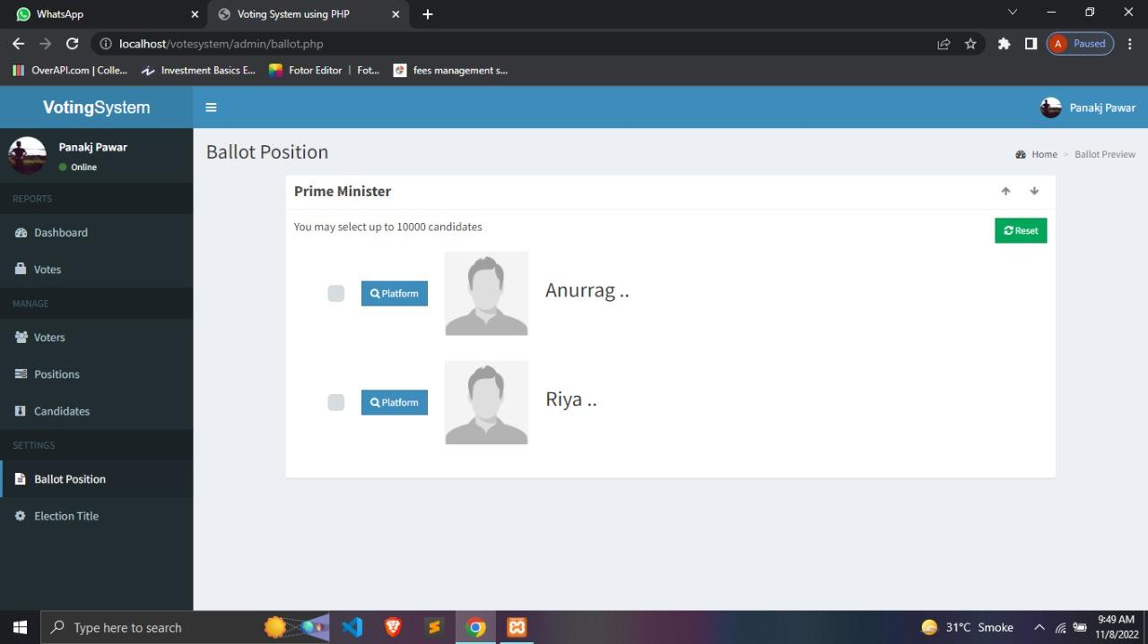

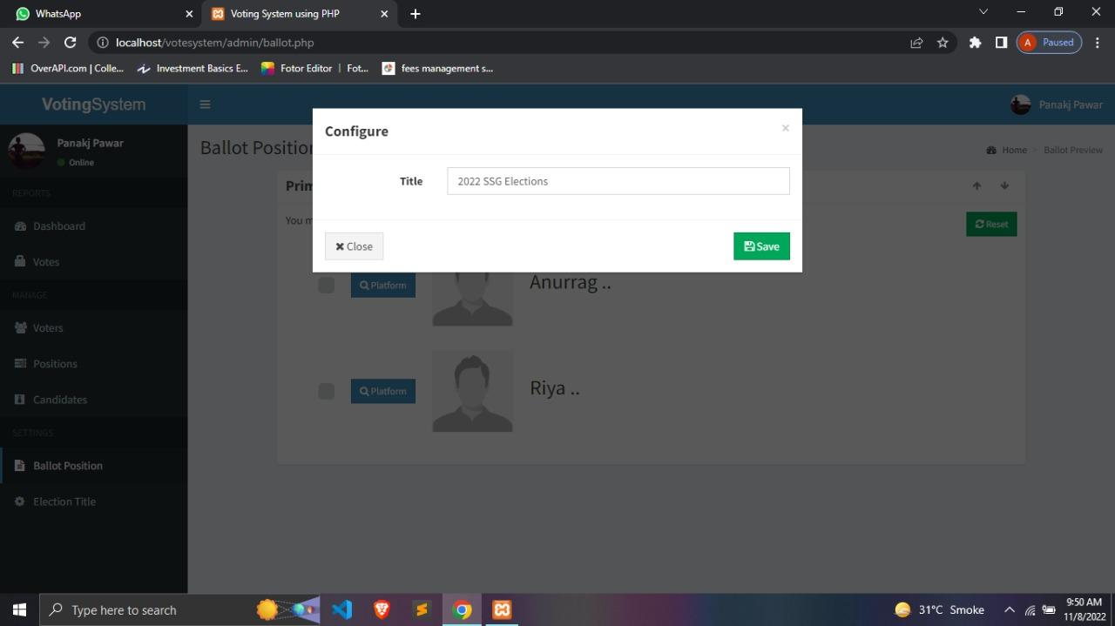

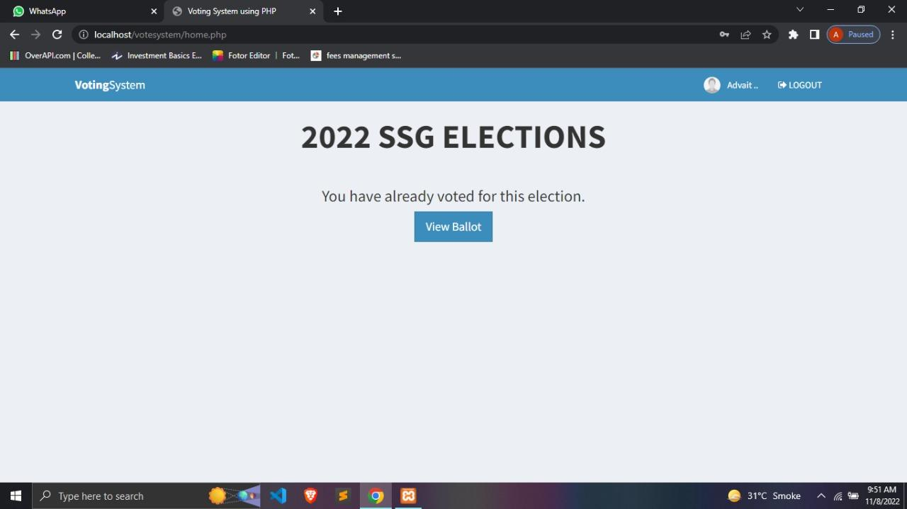

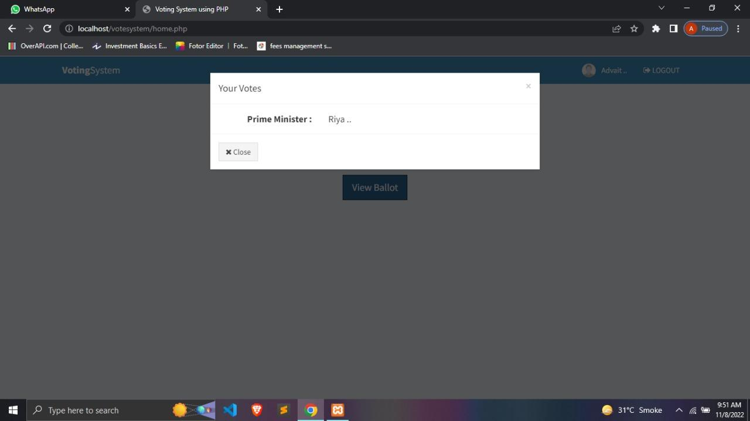

## CHAPTER 7

**DEPLOYMENT, MAINTENANCE & CONCLUSION**

## Conclusion

* 1. **Deployment**

Deployment, in the case of a website, means uploading the website on a suitable server.

Preparing content of the website

Designing and building the website

Finding a web hosting

Doing a quality assurance audit

Choosing website upload method

Publish website

Import database

Checking if the website works

Our website will not more than 1GB of space at initial stage

Charges

The average cost to rent a small server is Rs.7,953/- to Rs.15,907/- per month.

Free hosting allows hosting and comes with 10GB storage, unlimited bandwidth and one e-mail account.

Paid hosting (Rs.635.55/month) allows hosting unlimited sites and includes unlimited disk space, bandwidth, multiple email accounts and many more features.

Interconnection of database and server

Connect to a SQL server instance

Create a database

Query the tables and view results

A database is connected to the server so that the website can access the data of voters, parties,etc.

* 1. **Maintenance**

Maintenance refers to ensuring the smooth functioning of the website, correcting the errors and if possible preparing for the next version.

Some of the errors such as “can’t connect to the server” may occur due to a number of technical issues. First the problem must be identified and then fixed.

Recovery plan for website if it crashes

* 1. **Conclusion**

In this study, we proposed an Online voting system. In this project we develop a system that will allow users to register in the system to vote from anywhere at their convenience.Our online portal gives voters a chance to cast his vote via the internet without going to a voting booth.This system gives fast access, more security levels, high flexibility and efficiency. It also eliminates the chances of a fake person casting a vote or bogus voting. It also reduces manpower and unwanted human errors. It provides quick results of elections which are completely accurate. Our system focuses on reducing the time and paperwork. Hence the online voting system makes all the voting process fast and gives security to the votes.

## Acknowledgement

As every project is ever complete with the guidance of experts. So we would like to take this opportunity to thank all those individuals who have contributed in visualizing this project.

We express our deepest gratitude to our project guide Prof. Rishikesh Yadav(CSE(AIML/IOT) Department, Smt. Indira

Gandhi College of Engineering, University of Mumbai) for his valuable guidance, moral support and devotion bestowed on us throughout our work.

We would also take this opportunity to thank our project coordinator Prof. Sarita Khedikar for her guidance in selecting this project and also for providing us all the details on proper presentation of this project.

We extend our sincere appreciation to our entire professors from Smt. Indira Gandhi College of Engineering for their valuable inside and tip during the designing the project. Their contributions have been valuable in many ways that we find it difficult to acknowledge them individually.

We are also grateful to our HOD Prof. Sonali Deshpande for extending his help directly and indirectly through various channels in our project.

If I can say in words I must at the outset my intimacy for receipt of affectionate care to Smt. Indira Gandhi College of Engineering for providing such a simulating atmosphere and wonderful work environment.

## References

* https://en.wikipedia.org/wiki/Visual_Studio_Code
* https://en.wikipedia.org/wiki/XAMPP
* <https://www.javatpoint.com/software-engineering-spiral-model>
* <https://www.geeksforgeeks.org/project-idea-online-voting-portal/>
* <https://www.geeksforgeeks.org/software-engineering-spiral-model/>
* <https://www.campcodes.com/>
* <https://www.geeksforgeeks.org/php-tutorials/>
* Online Election System with Documentation and Source code: College Project using Php and Mysql Paperback – Import, 19 May 2021 by Parames Jp (Author)